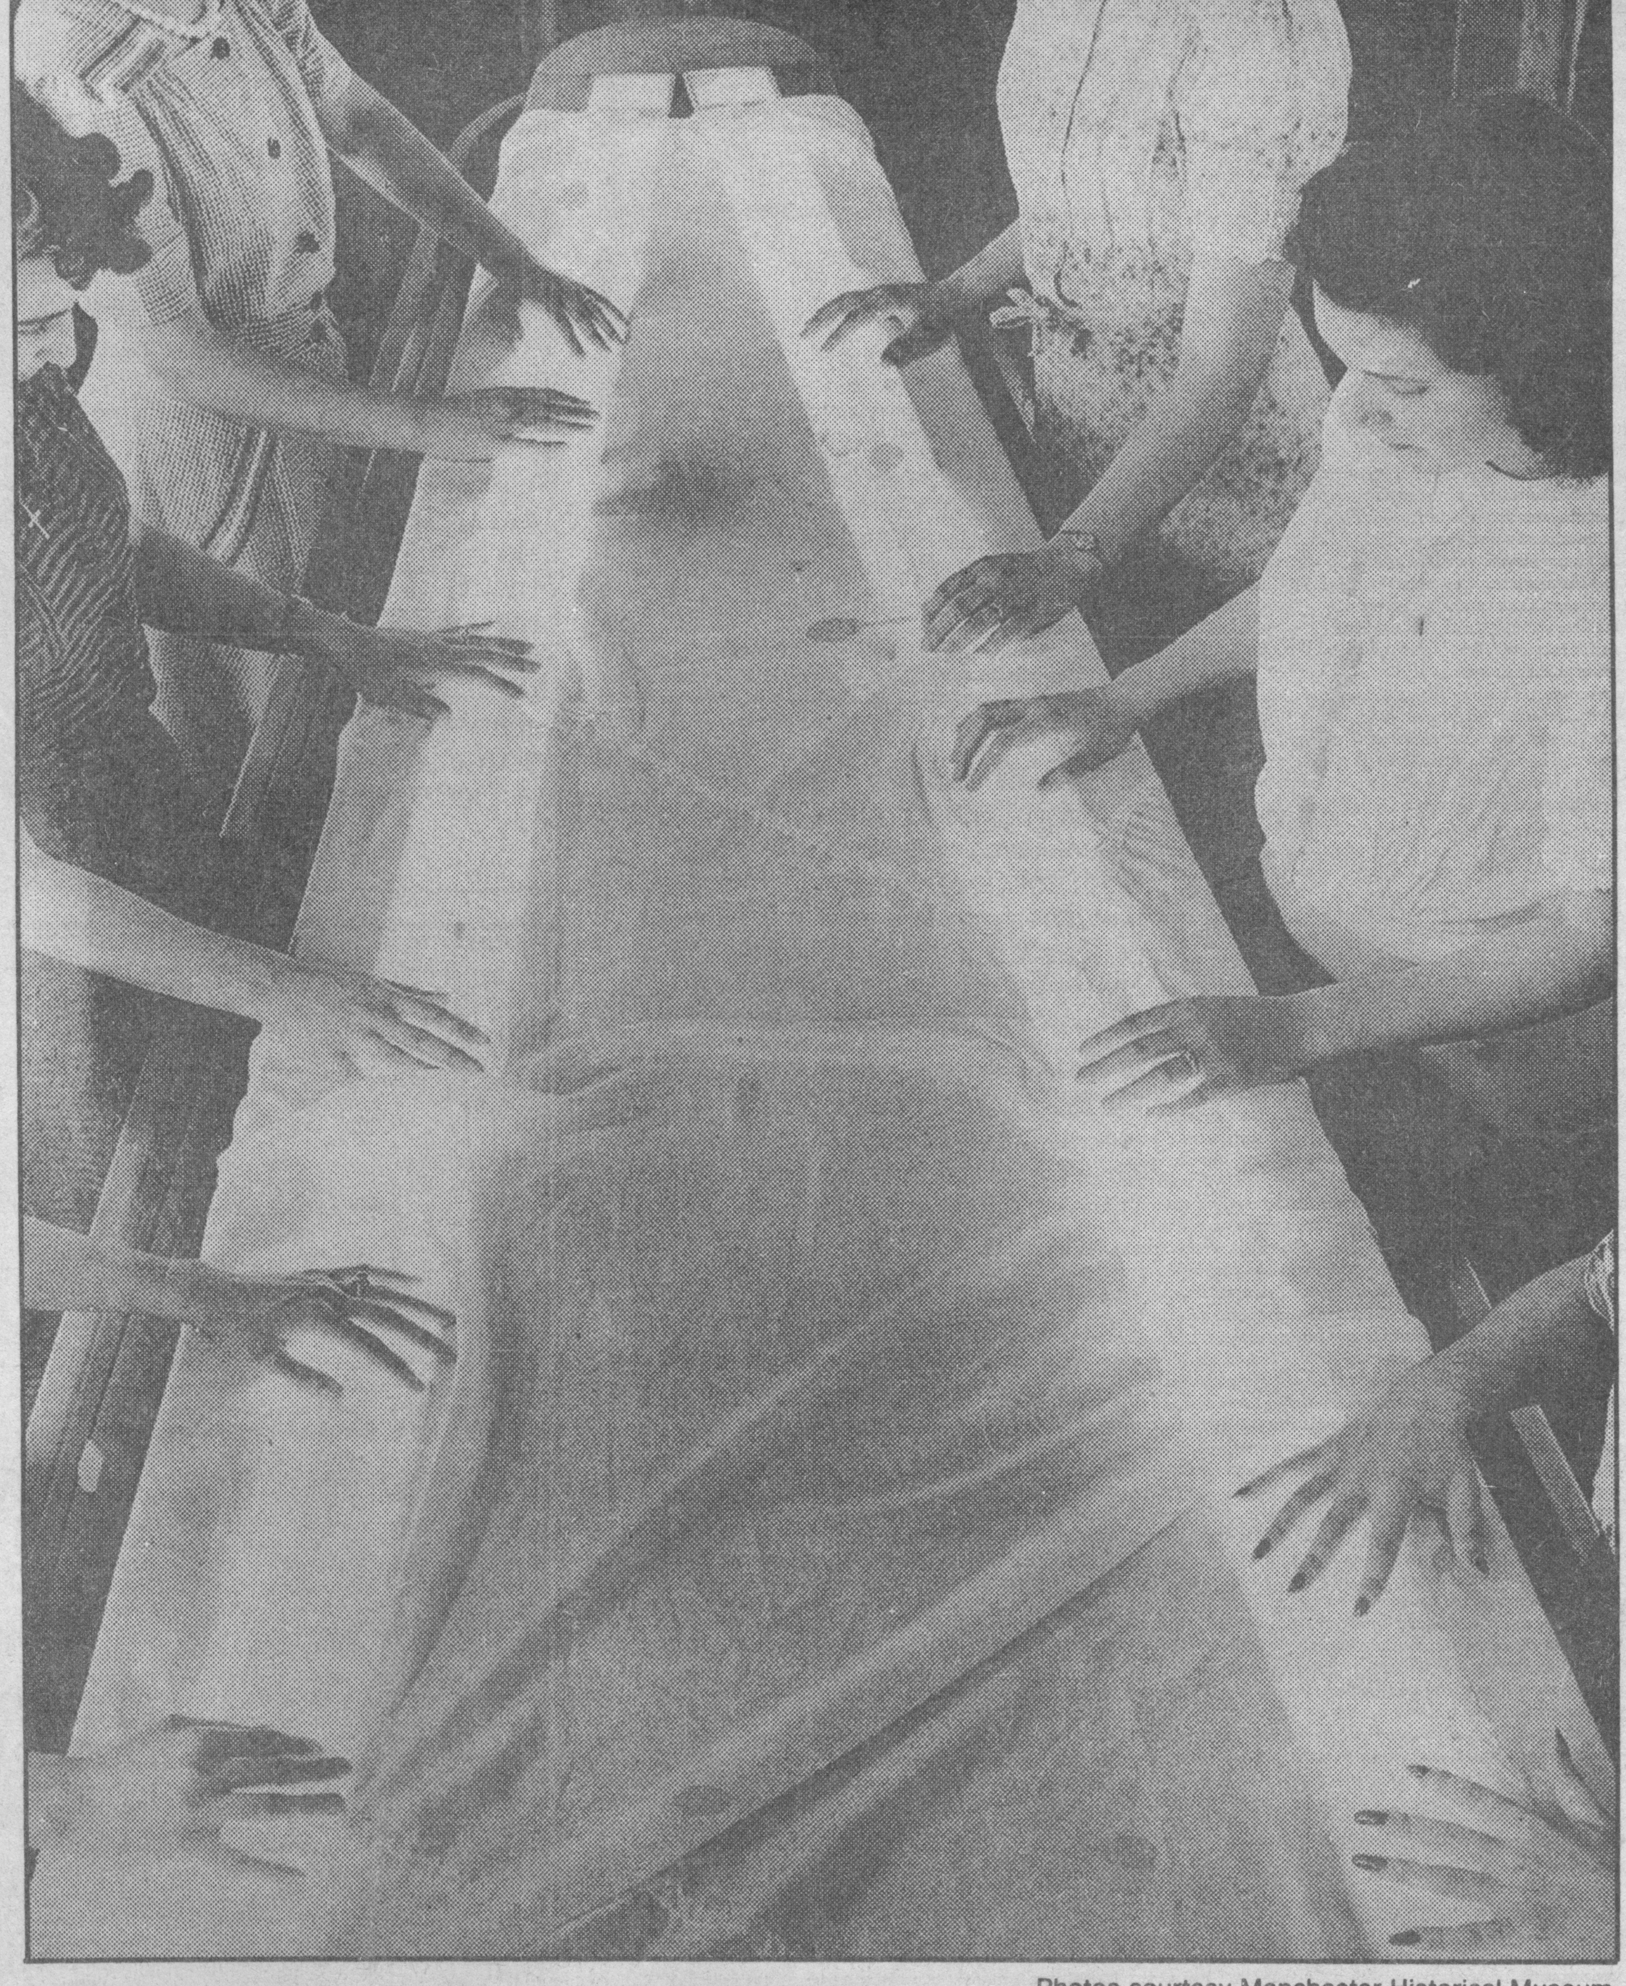 **Town Courant, Hartford Courant**

Section H, Feb. 2, 1992

The Pioneer Parachute Co., a subsidiary of Cheney Bros., was a primary producer of parachutes for the U.S. during World War II. Pioneer Parachute employees' skillful hands examine every square inch of canopy as it is spread over illuminated inspection table.

**War kept Cheney Bros. humming 24 hours a day**

**By Lucille Renwick,** Courant Staff Writer

MANCHESTER -- Joseph Sartor can't quite remember what he was doing when Pearl Harbor was bombed 50 years ago. It is a faded blur now to the 77-year old Manchester native.

But Sator does recall thinking that the Cheney Bros. factories, where he worked, would be deluged with requests for equipment for soldiers. He was correct.

"It was pretty chaotic at times. There was always work being done and people moving all over the place, but it was a good feeling," said Sartor, the uncle of Manchester General Manager Richard Sartor.

From 1941 to 1946, Cheney Bros. and its subsidiary, Pioneer Parachute Co., became one of the nation's primary producers of Army and Navy parachutes.

The war transformed the factories into mini-military plants that churned out products, opened up jobs for women from throughout the North, and created a new reputation for the Cheney factories.

"They received a bountiful supply of parachute business from the government," said Jeff Robinson, 93 of Center Street, who worked for Cheney Bros. for over 40 years.

Pioneer Parachute, which Cheney Bros. had bought in 1938, concentrated on making the parachutes and other products, including clothing, while Cheney Bros. made the cloth.

More than 75 percent of Cheney Bros. efforts were devoted to producing materials for the war. More than 2,000 people worked for Cheney and another 3,000 worked for Pioneer Parachute.

In addition to parachutes, Pioneer also made silk cartridge bags, aerial delivery chutes, nylon mosquito netting, nylon tent fabric, alpaca and wool pile coats, ties and "bombchutes" used to drop cargo from airplanes.

The war brought a death of workers at the factories - with most of the men who worked for Cheney Bros. and Pioneer Parachute leaving to fight - and forced the Cheneys to travel north to find more women to fill the jobs.

They went up to New Hampshire, Vermont and Maine to recruit women, mostly, to help run the machines. Most of the women came straight out of high school from small towns where there wasn't much industry.

"At one time Pioneer Parachute had a big house on Otis Street called Pioneer House and the women, why they recruited, lived there," said Martha Seavey, 67, who started working at Pioneer Parachute in 1943, after she graduated from Manchester High School.

Other women, many in their 20s, lived in some of the old Cheney houses on Forest Street and a large house at Chestnut and Locust streets, which is now a nursing home.

The women were trained quickly and put on the looms to weave the cloth, or on eh machines to sew the parachutes together.

Silk, the trademark material of the Cheney family factories, was the first material used in parachutes but was quickly replaced by nylon. Cheney Bros. printed the camouflage designs on the parachute material.

Sartor worked in the printing department of Cheney Bros., affixing the green- and brown-shaded patches on the cloth before leaving in 1943 to fight in the war.

"We were under a little bit of pressure. We were put on extended time to put out more printed cloth," he said.

"Everything was uptight. It was a big thing then because everything got busy," said Burton Smith, 69, who worked for Cheney Bros before enlisting.

To keep up with the demand for military supplies, the factories increased workers' hours and added additional shifts to rotate people and keep the factories open almost 24 hours.

The extra hustle was exciting for many workers, including Seavey, who worked in the personnel office, and Elsie Peterson, 82, who inspected the parachutes.

"It was really humming there all the time, really very busy," Seavey said.

Workers would constantly flood her personnel office, signing up to buy war bonds as a way to get involved.

To boost workers' spirits, baseball players from Boston and New York would visit the factories and sign autographs, Peterson recalled.

The giant factory rooms were a continuous buzz of machines threading and twisting the thin strands of fiber into cloth and then stitching them into parachutes or coats or mosquito nets. Each floor had a different wing where they made various products for the war.

Several of the looming machines were designed to run automatically for 24 hours to keep a constant flow of material for the seamstresses.

During the war, Cheney Bros. used over 13 million pounds of cotton, rayon, nylon, mohair and other materials in addition to weaving silk. It produced over 62 million yards of cloth for the government, more than enough to circle the world twice at the equator. The company also made over 1,000 tons of yarns and threads and over 44 million yards of braided cord.

Pioneer Parachute Co. won five Army-Navy "E" awards - for excellence - two U. S. treasury awards for war-bond payroll deductions and one safety citation during the five years it worked on government contracts for the war.

By the start of 1946, about six months after the end of the war, the contracts for parachutes slowed down. The looms and machines that once shook the 12-foot-tall factory windows stood silent. Some were shipped south. For Cheney Bros., World War II was over and a long, slow decline had begun.